ỦY BAN NHÂN DÂN TP. HCM CỘNG HÒA XÃ HỘI CHỦ NGHĨA VIỆT NAM
TRƯỜNG CAO ĐẲNG LÝ TỰ TRỌNG TP.HCM Độc lập – Tự do – Hạnh phúc
________________ ____________

ĐỀ THI GIỮA HỌC PHẦN LÝ THUYẾT
SCORES:
HỌC PHẦN: NGHE 1 - HỌC KÌ: I - NH: 2017 - 2018
BẬC ĐÀO TẠO: TRUNG CẤP CHUYÊN NGHIỆP
NGÀY THI: …../……/2017 THỜI GIAN THI: 45 PHÚT

NAME: ………………………………………….. CLASS:…………………….

Task 1: (6 x 0.25 = 1.5p)
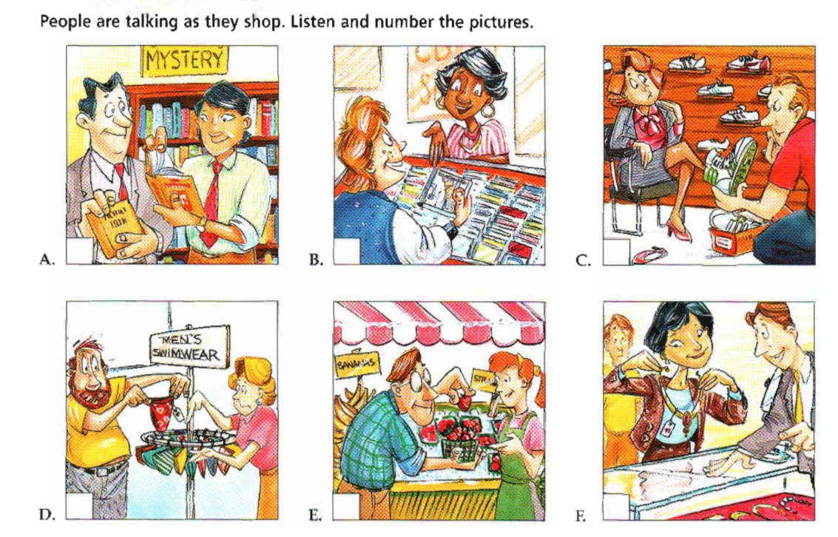

Task 2: (8 x0.25=2p)
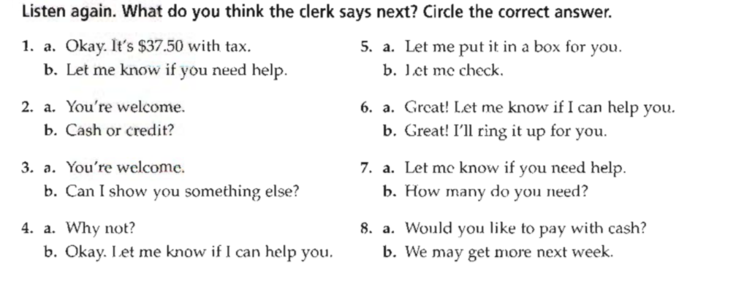

Task 3a: (4 x0.25 = 1p)
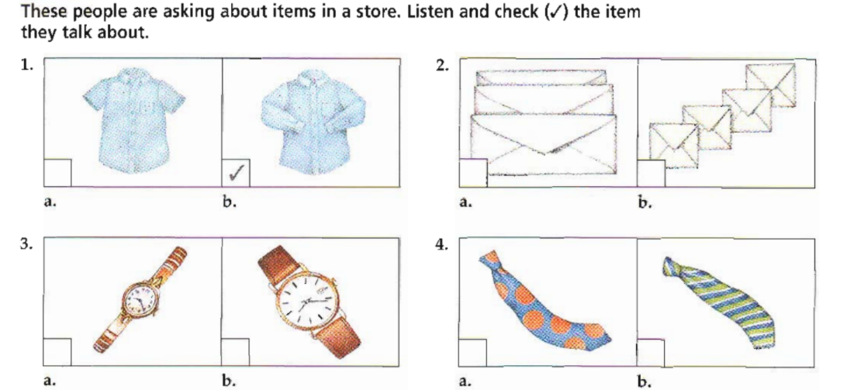

Task 3b: (6x0.25=1.5p)

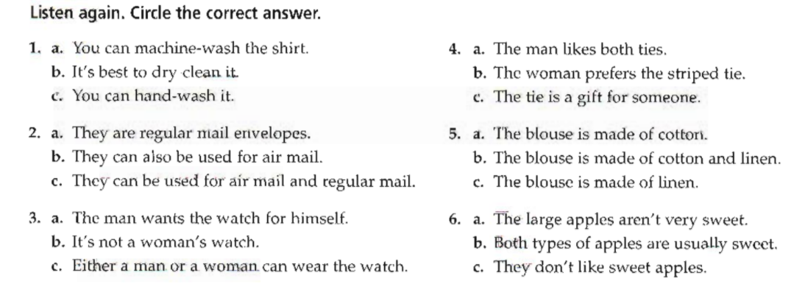
Task 4: Listen and fill in the blanks (16 x 0.25 = 4p)

My first (1)……………………….. of Alexander was that he was much older than me. In (2)……………………….., he was 32 but I (3) ……………………… he was older. But when we (4) …………………………. talking, I (5) ……………………………. liked him. He was extroverted and funny, and he had a very good (6)………………………...... of (7)……………………………. He (8)…………………………. (9)……………………….. a TV (10)……………………………, and he (11)……………………………… me a lot of good (12)…………………………… about his (13)…………………………. He was also (14)……………………………….in the same thing as me – (15)……………………………. and music. And we (16)……………………….. a lot about that.

--The end --

